ST. XAVIER’S COLLEGE

**(Affiliated to Tribhuvan University)**

**Maitighar, Kathmandu**



**Database Management System**

**Theory Lab Assignment #7**

**SUBMITTED BY:**

Sneha Prasai

013BSCCSIT040

**SUBMITTED TO**

|  |  |
| --- | --- |
| **Er. Sanjay Kr. Yadav**  **( Lecturer )** |  |
| **Department of Computer Science** | |

1. Find the eno, ename, salary of the employee whose salary is >4000.

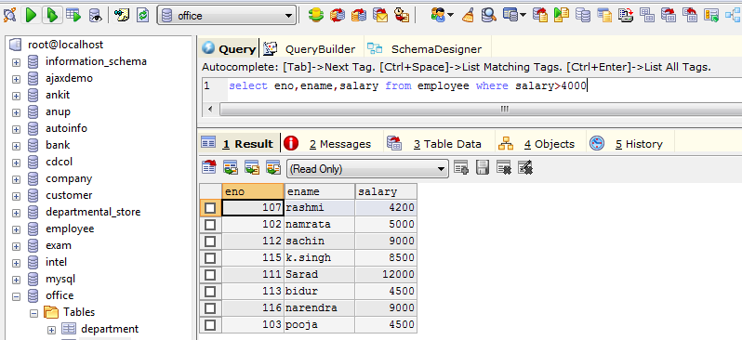

1. Find eno,enmae,salary of the employee whose salary >5000 and job status is professor.

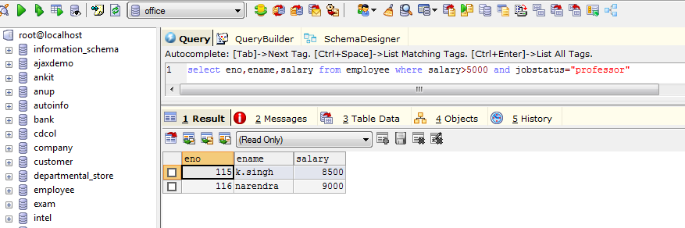

1. Removing duplicate

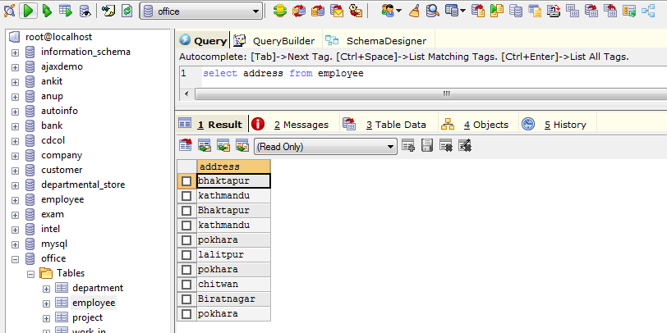

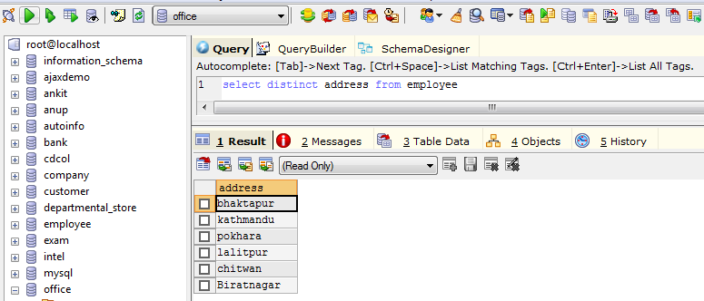

1. Find eno,ename,salary of employee whose department number 20 or jobstatus research field.

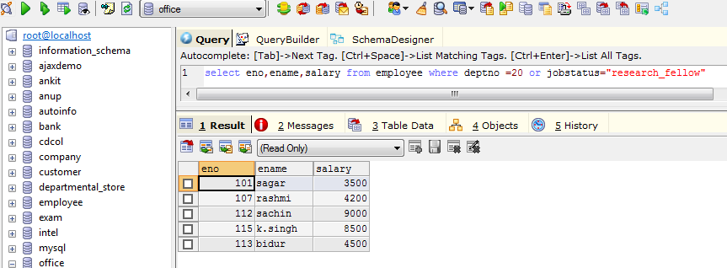

1. Find the eno,ename,age and salary from the employee where the age is between 24 and 28

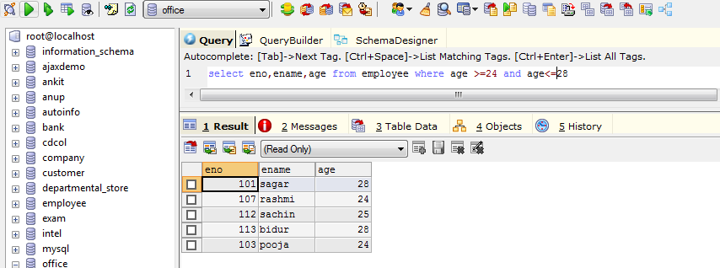

1. Select or find eno,ename whose start with ‘Sa’

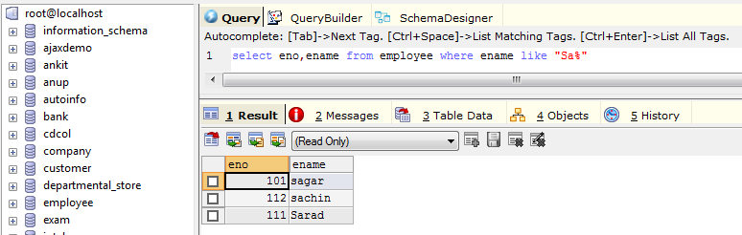

1. List all employee names with their project name

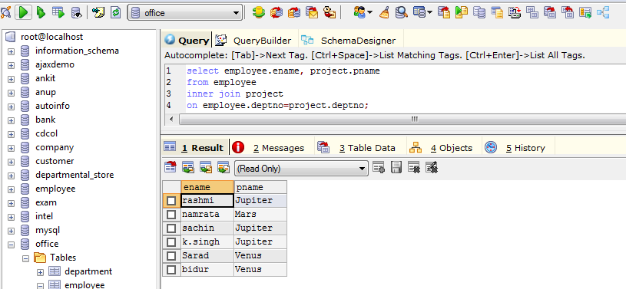

1. List name of all employee and their salary who are working in project marks or venus

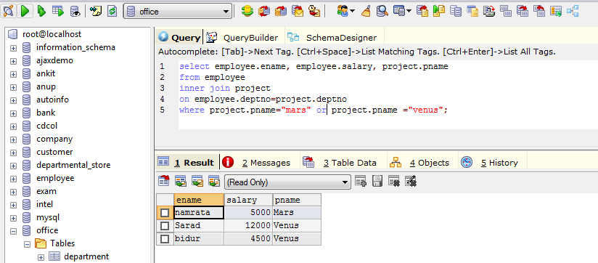

1. List name of all employee and their salary who are working in project earth and venus
2. List name and address of all employee who works in department which is located in pokhara

